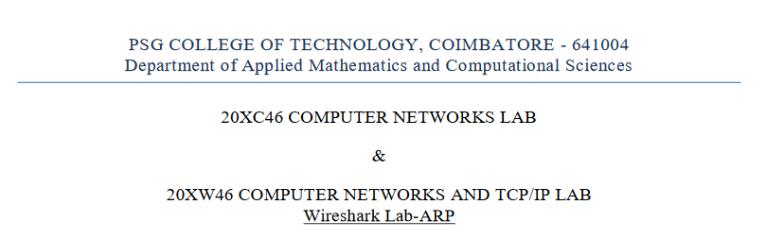

By: A. Abishek- 20pw01

Step 1:

1.

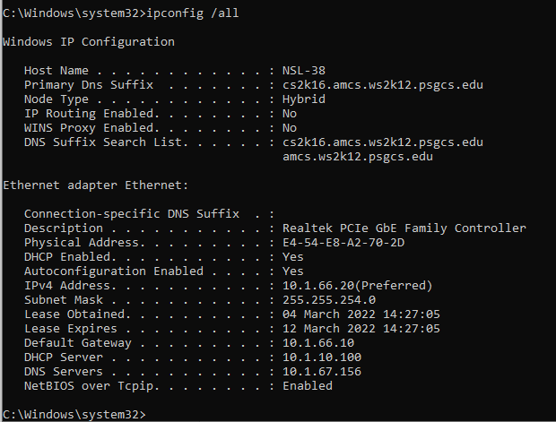

IP: 10.1.66.20

Mac: E4-54-E8-A2-70-2D

Default Gateway: 10.1.66.10

2.

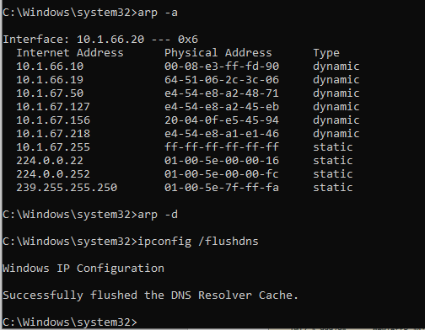

3.

